**EXAMPLE FOR ANONYMOUS BLOCKS:**

* **Executable section only(minimum required):**

BEGIN

DBMS_OUTPUT.PUT_LINE('PL/SQL is easy!');

END;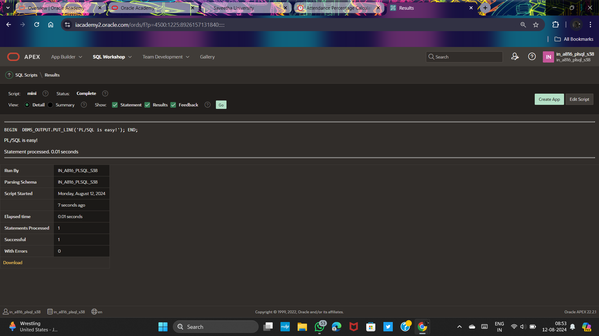

* **Declarative and executable sections:**

DECLARE

v_date DATE := SYSDATE;

BEGIN

DBMS_OUTPUT.PUT_LINE(v_date);

END;

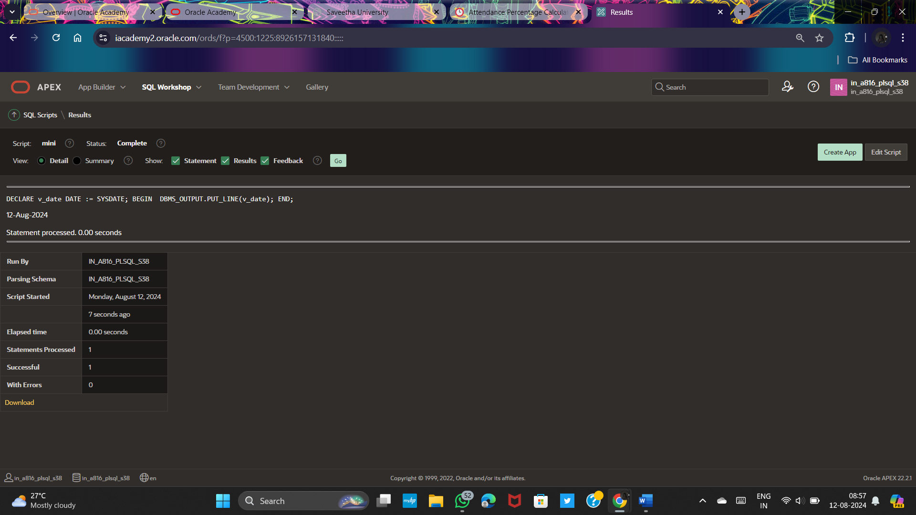

**Example of anonymous blocks:**

* **Declarative,executable and exception sections:**

DECLARE

v_firstname VARCHAR(25);

v_lastname VARCHAR(25);

BEGIN

SELECT firstname,lastname

INTO v_firstname,v_lastname

FROM copyemp

WHERE lastname = 'govindaraju';

DBMS_OUTPUT.PUT_LINE('the employee of the month is:'||v_firstname||''||v_lastname||'.');

EXCEPTION

WHEN TOO_MANY_ROWS THEN

DBMS_OUTPUT.PUT_LINE('Your select statement retrieved multiple rows.consider using a cursor or changing the search criteria.');

END;

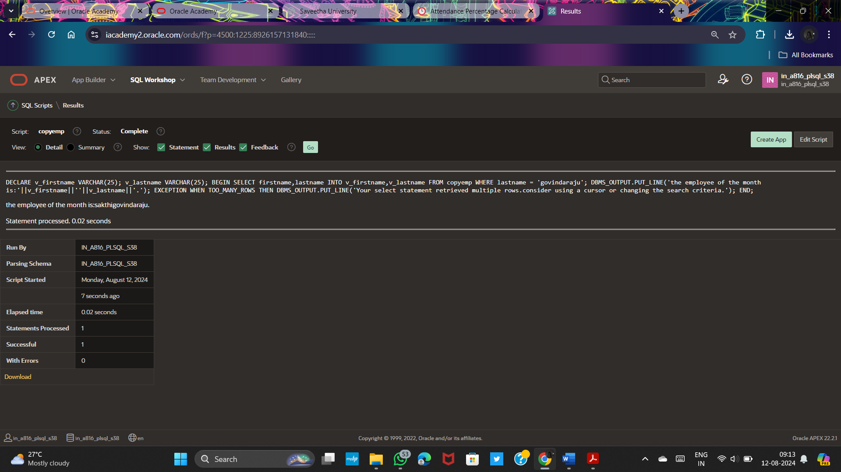

SELECT TOMORROW(SYSDATE) AS "Tomorrow Date"

FROM DUAL;

BEGIN

DBMS_OUTPUT.PUT_LINE(TOMORROW(SYSDATE));

END;

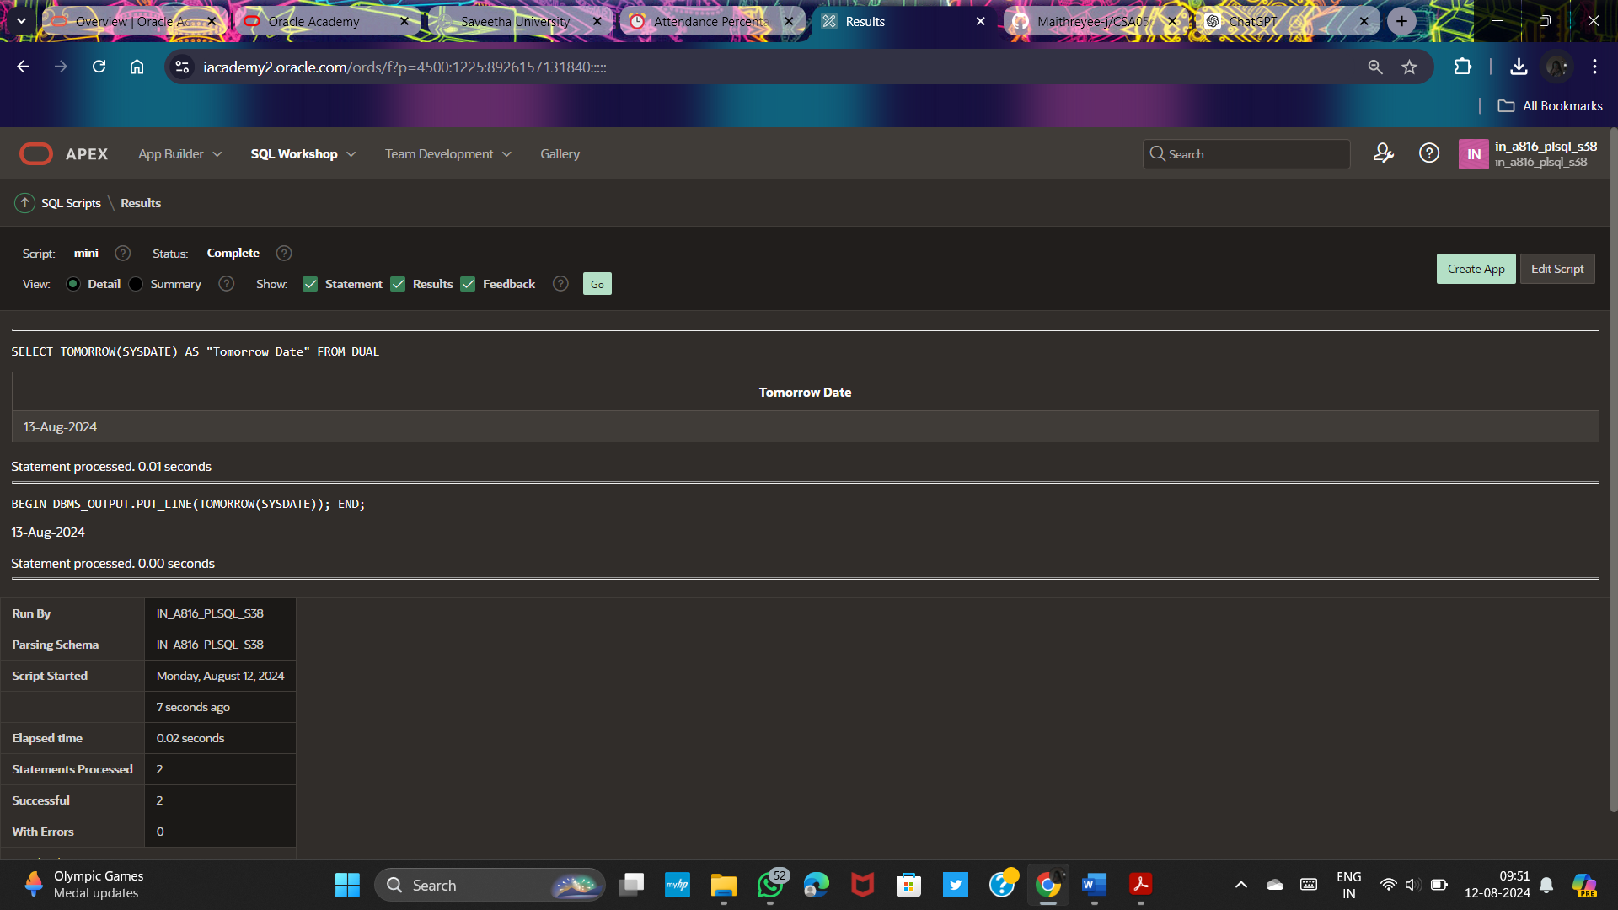

**Sum of N natural numbers:**

DECLARE

a integer := 10;

b integer := 20;

c integer;

f real;

BEGIN

c := a + b;

dbms_output.put_line('Value of c: ' || c);

f := 70.0/3.0;

dbms_output.put_line('Value of f: ' ||f);

END;

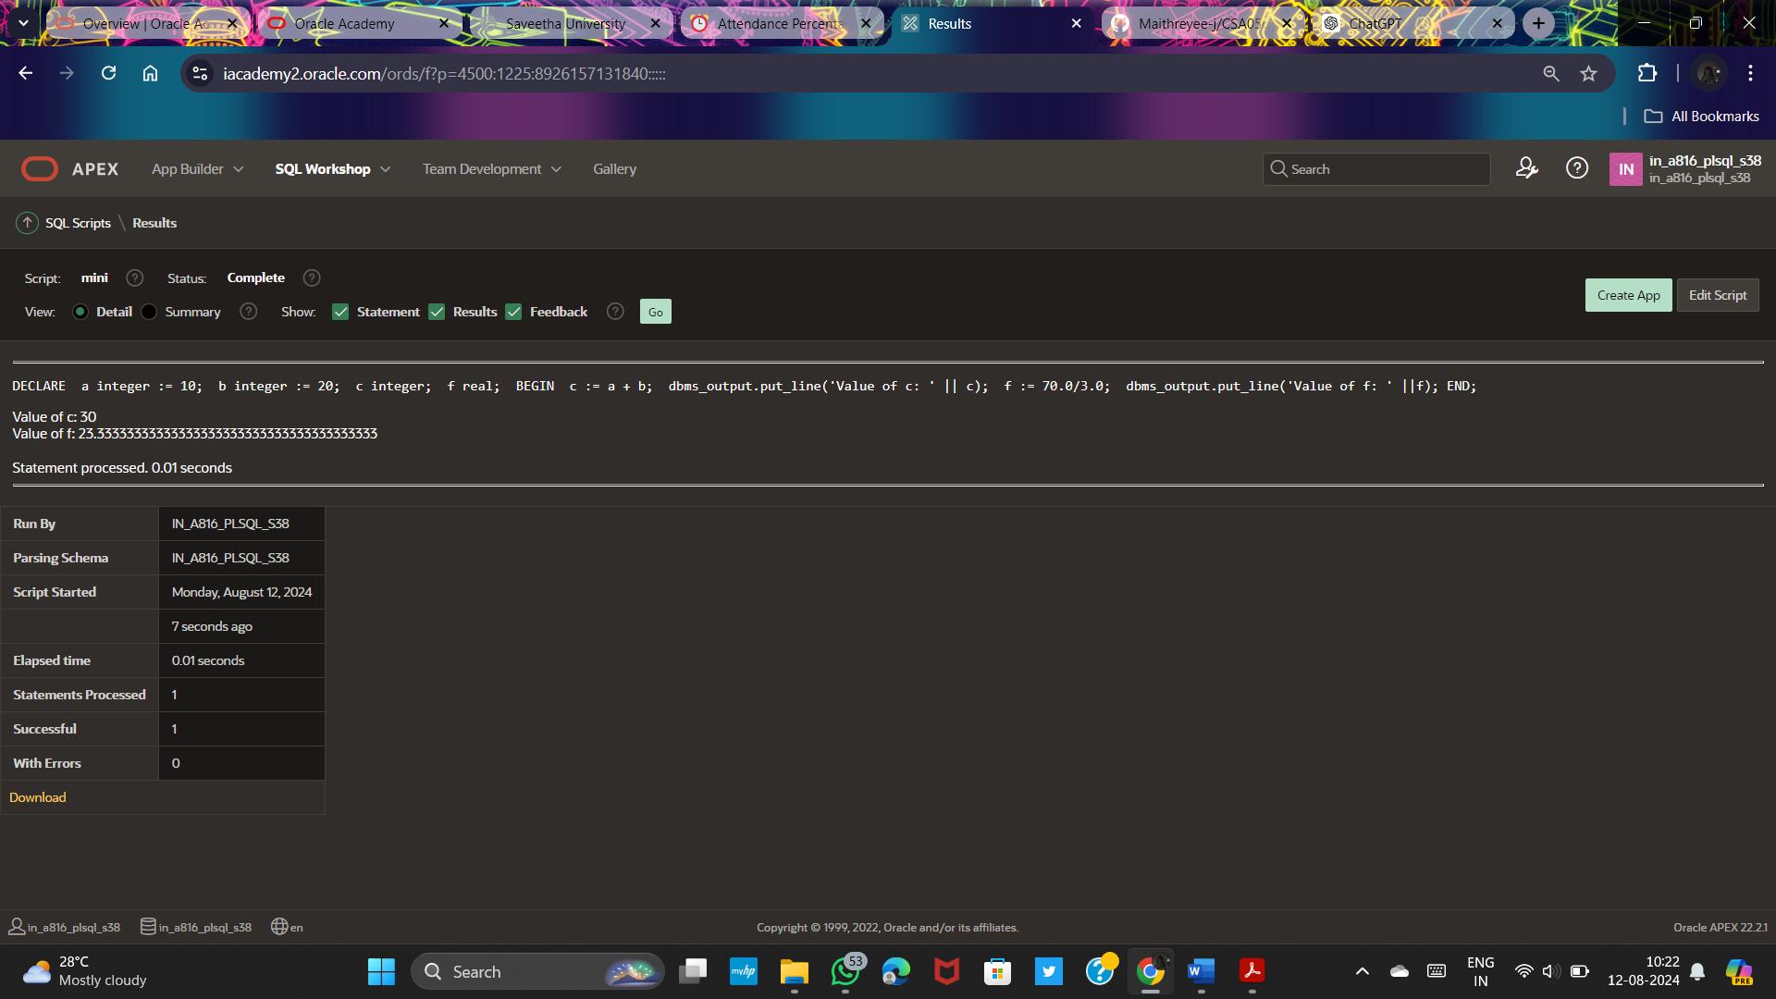

**Area and circumference:**

DECLARE

-- constant declaration

pi constant number := 3.141592654;

-- other declarations

radius number(5,2);

dia number(5,2);

circumference number(7, 2);

area number (10, 2);

BEGIN

-- processing

radius := 9.5;

dia := radius * 2;

circumference := 2.0 * pi * radius;

area := pi * radius * radius;

-- output

dbms_output.put_line('Radius: ' || radius);

dbms_output.put_line('Diameter: ' || dia);

dbms_output.put_line('Circumference: ' || circumference);

dbms_output.put_line('Area: '||area);

END;

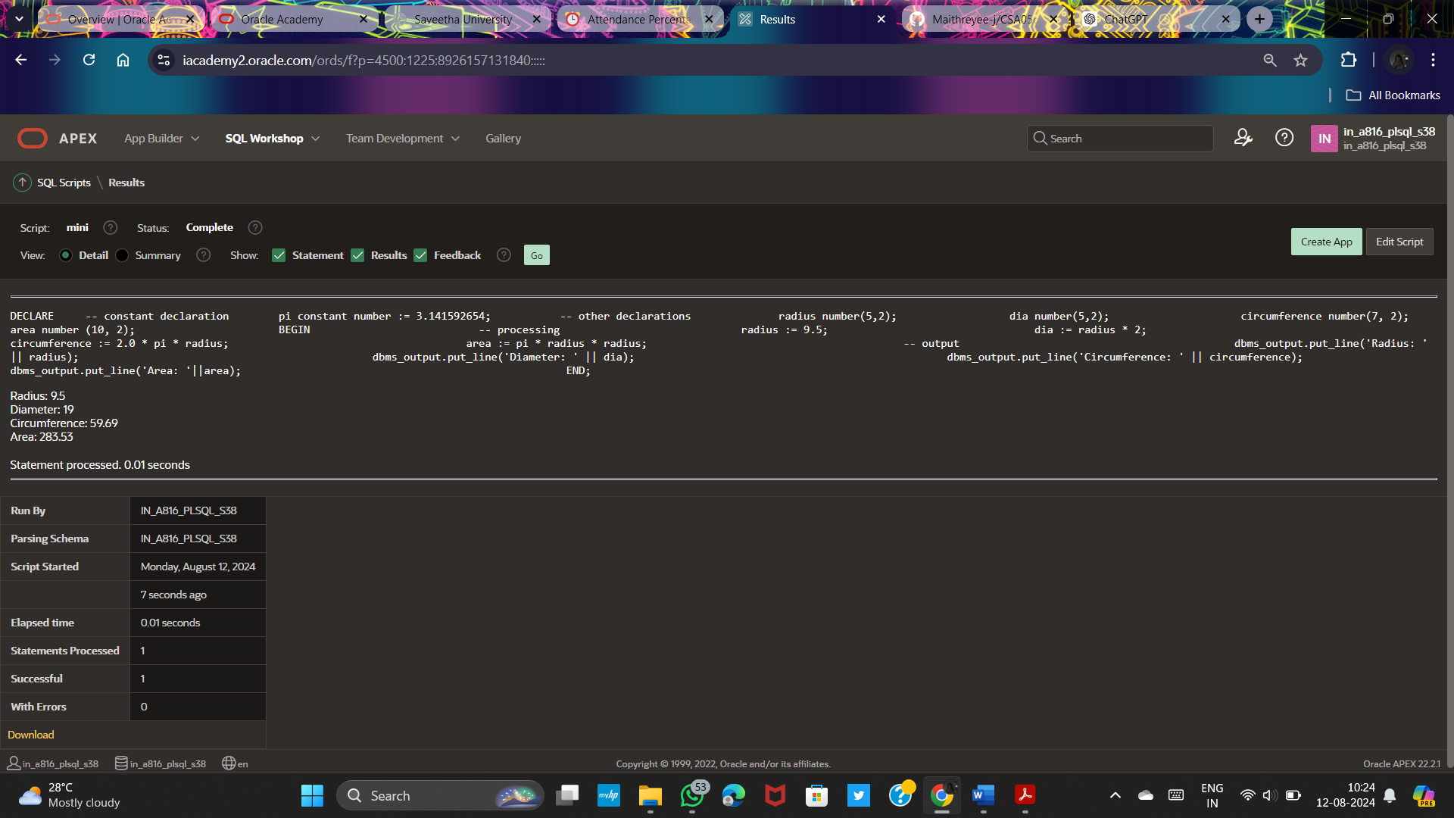

**Count of words and characters:(for loop)**

DECLARE

str VARCHAR2(40) := 'Tutorials Point';

nchars NUMBER(4) := 0;

nwords NUMBER(4) := 1;

s CHAR;

BEGIN

FOR i IN 1..Length(str) LOOP

s := Substr(str, i, 1);

nchars:= nchars+ 1;

IF s = ' ' THEN

nwords := nwords + 1;

END IF;

END LOOP;

dbms_output.Put_line('count of characters is:'||nchars);

dbms_output.Put_line('Count of words are: '||nwords);

END;

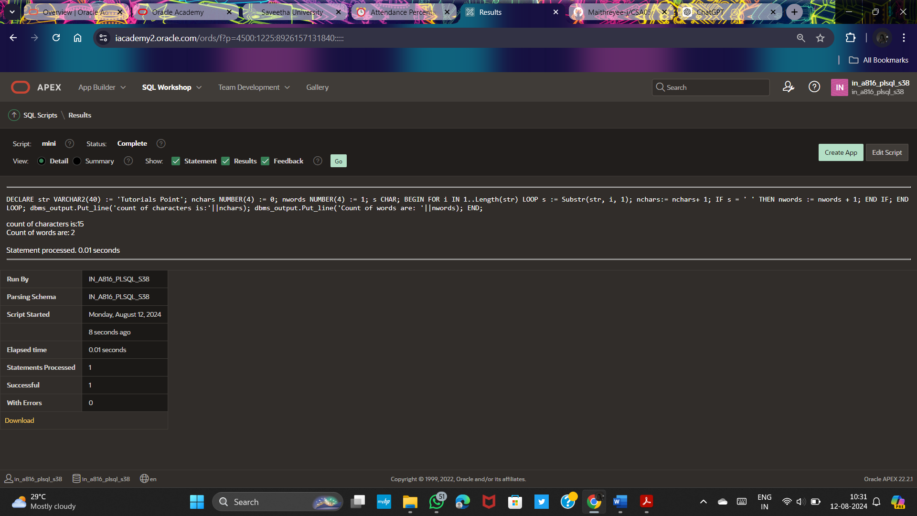

**Using DBMS_OUTPUT.PUT_LINE Example:**

DECLARE

v_result NUMBER;

BEGIN

v_result := 10*25;

DBMS_OUTPUT.PUT_LINE(v_result);

END;

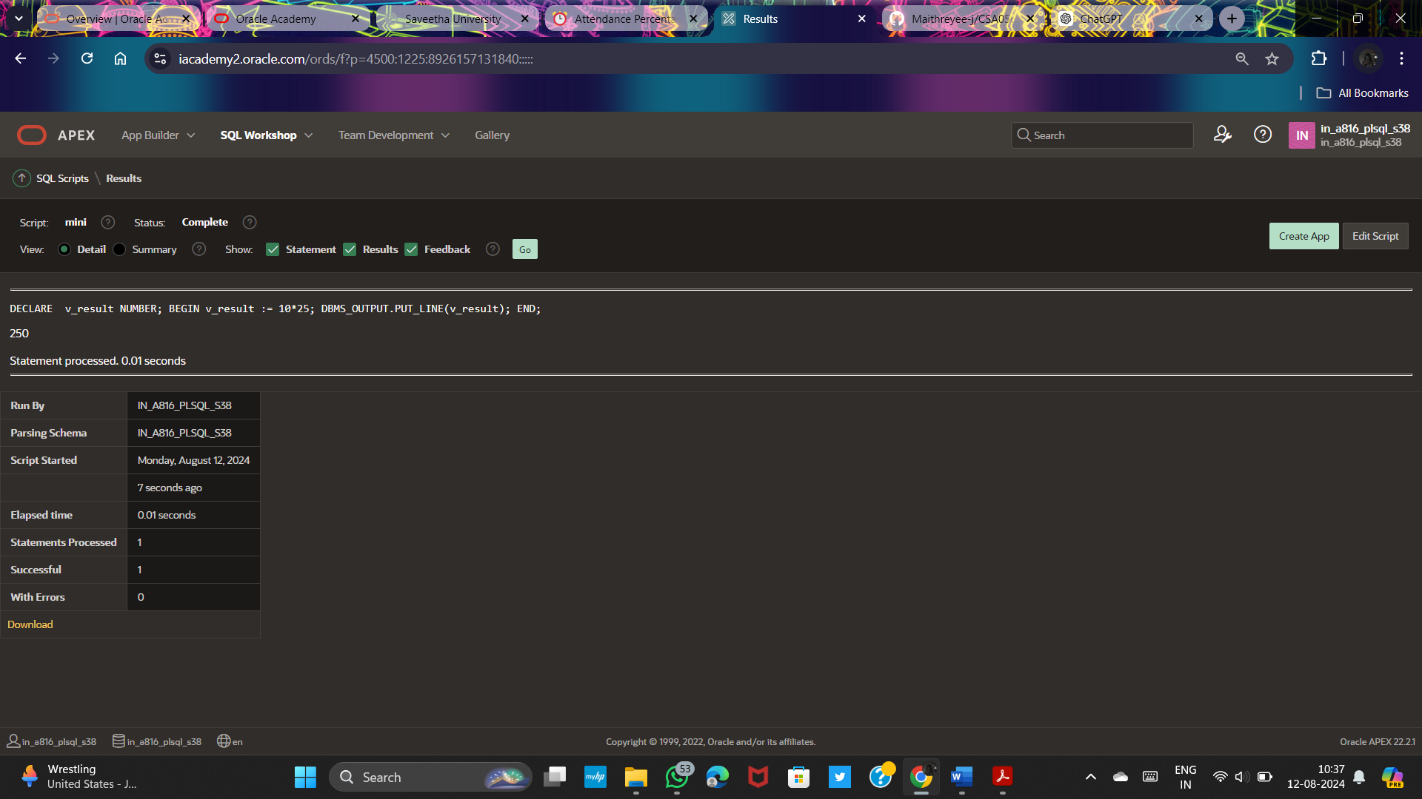

**Array:**

DECLARE

type namesarray IS VARRAY(5) OF VARCHAR2(10);

type grades IS VARRAY(5) OF INTEGER;

names namesarray;

marks grades;

total integer;

BEGIN

names := namesarray('Kavita', 'Pritam', 'Ayan', 'Rishav', 'Aziz');

marks:= grades(98, 97, 78, 87, 92);

total := names.count;

dbms_output.put_line('Total '|| total || ' Students');

FOR i in 1 .. total LOOP

dbms_output.put_line('Student: ' || names(i) || '

Marks: ' || marks(i));

 END LOOP;

END;

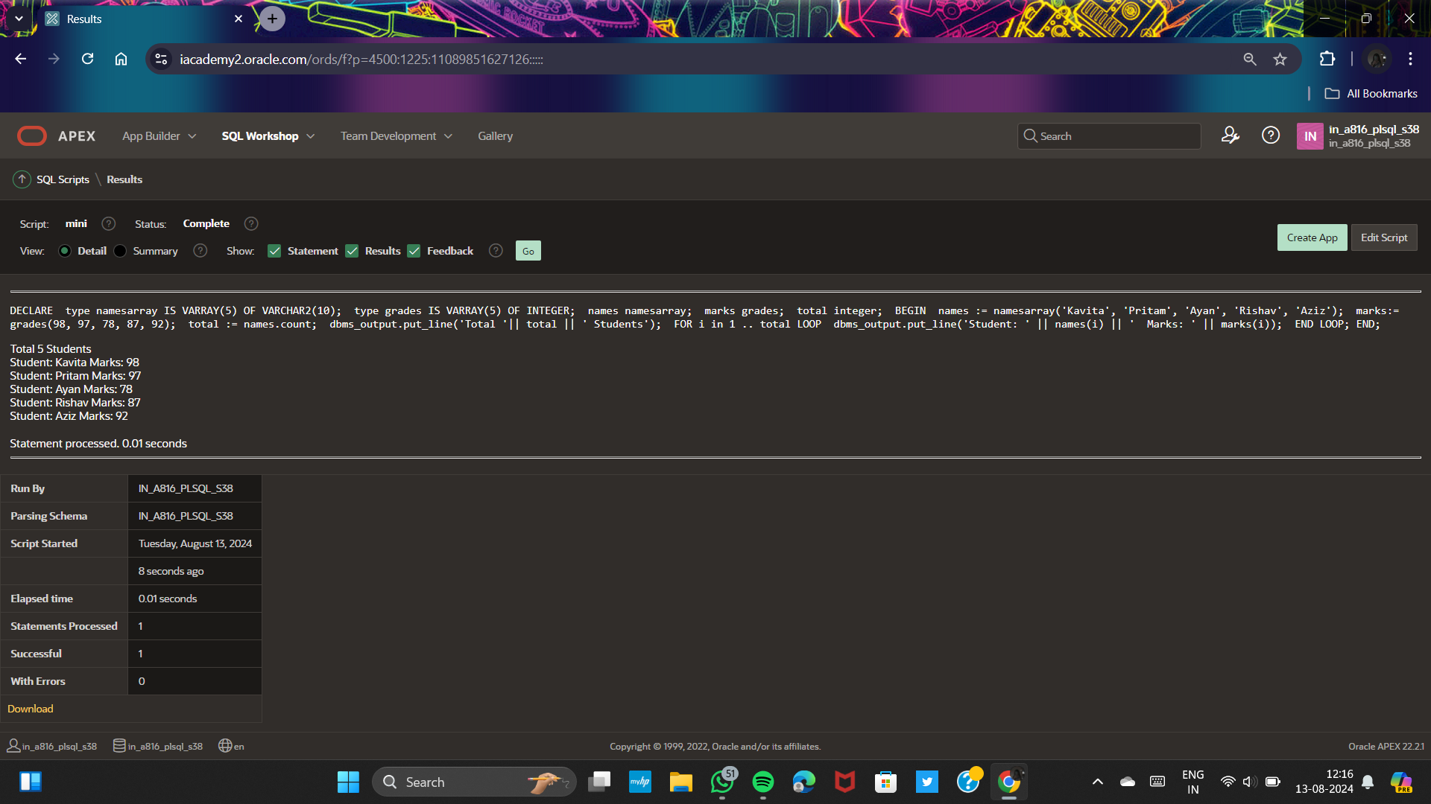

**Add FOR loop condition:**

DECLARE

type namesarray IS VARRAY(5) OF VARCHAR2(10);

type grades IS VARRAY(5) OF INTEGER;

type grade_labels IS VARRAY(5) OF VARCHAR2(2);

names namesarray;

marks grades;

total integer;

grade_label varchar(2);

BEGIN

names := namesarray('Kavita', 'Pritam', 'Ayan', 'Rishav', 'Aziz');

marks:= grades(98, 97, 78, 87, 92);

total := names.count;

dbms_output.put_line('Total '|| total || ' Students');

FOR i in 1 .. total LOOP

IF marks(i) >= 90 THEN

grade_label := 'A';

ELSIF marks(i) >= 80 THEN

grade_label := 'B';

ELSIF marks(i) >= 70 THEN

grade_label := 'C';

ELSIF marks(i) >= 60 THEN

grade_label := 'D';

ELSE

grade_label := 'F';

END IF;

dbms_output.put_line('Student: ' || names(i) || ' - Marks: ' || marks(i) ||' - Grade: ' || grade_label );

END LOOP;

END;

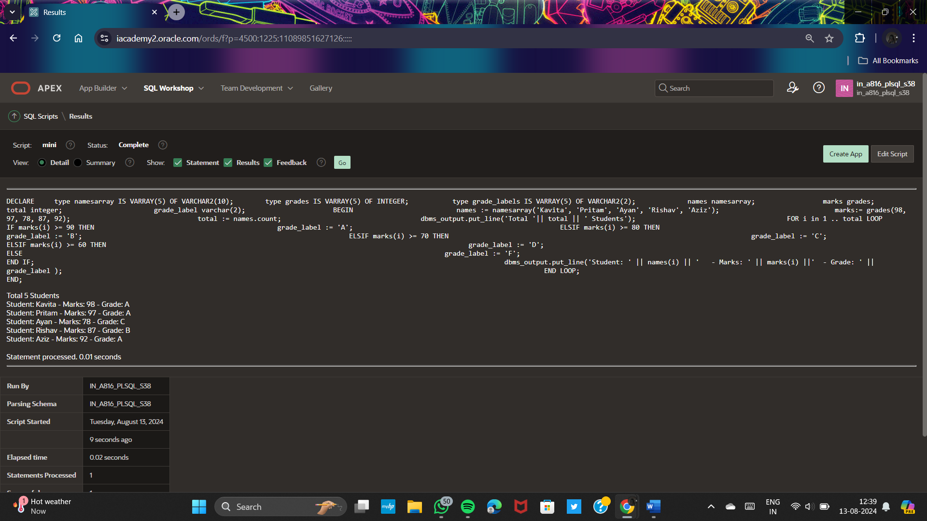

**Number of even and odd count:**

DECLARE

NUMBER_TO_CHECK NUMBER := 23146579;

ODD_COUNT NUMBER := 0;

EVEN_COUNT NUMBER := 0;

CURRENT_DIGIT NUMBER;

BEGIN

WHILE NUMBER_TO_CHECK > 0 LOOP

CURRENT_DIGIT := MOD(NUMBER_TO_CHECK, 10);

IF MOD(CURRENT_DIGIT, 2) = 0 THEN

EVEN_COUNT := EVEN_COUNT + 1;

ELSE

ODD_COUNT := ODD_COUNT + 1;

END IF;

NUMBER_TO_CHECK := TRUNC(NUMBER_TO_CHECK / 10);

END LOOP;

DBMS_OUTPUT.PUT_LINE('Count of odd digits: ' || ODD_COUNT);

DBMS_OUTPUT.PUT_LINE('Count of even digits: ' || EVEN_COUNT);

END;

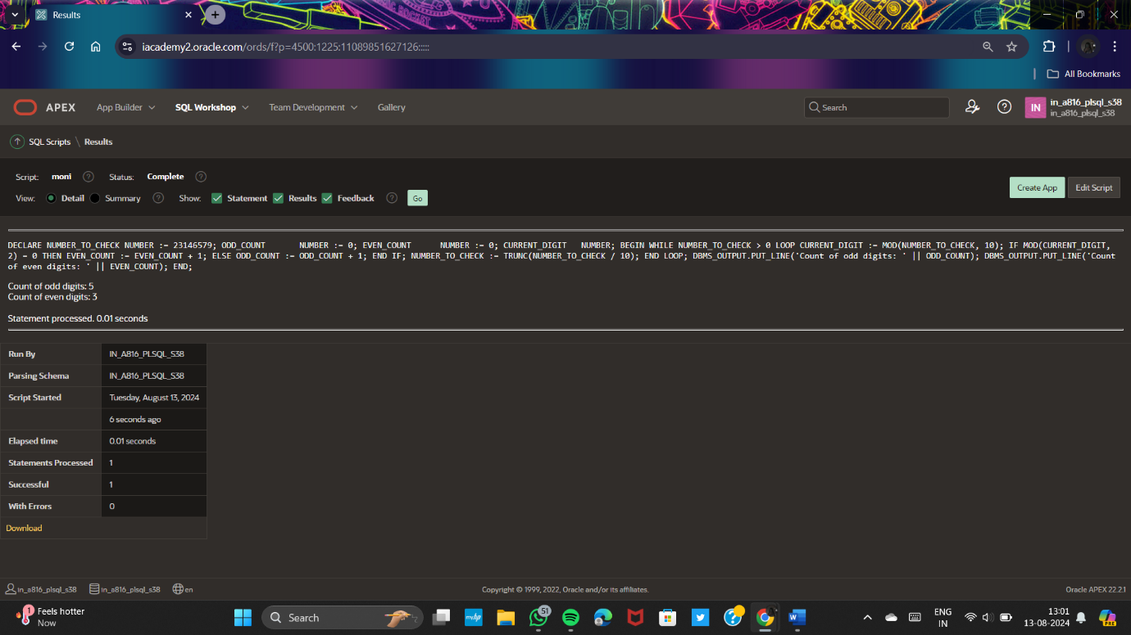

**Find the Minimum:**

DECLARE

a number;

b number;

c number;

PROCEDURE findMin(x IN number, y IN number, z OUT number) IS

BEGIN

IF x < y THEN

z:= x;

ELSE

z:= y;

END IF;

END;

BEGIN

a:= 23;

b:= 45;

findMin(a, b, c);

dbms_output.put_line(' Minimum of (23, 45) : ' || c);

END; 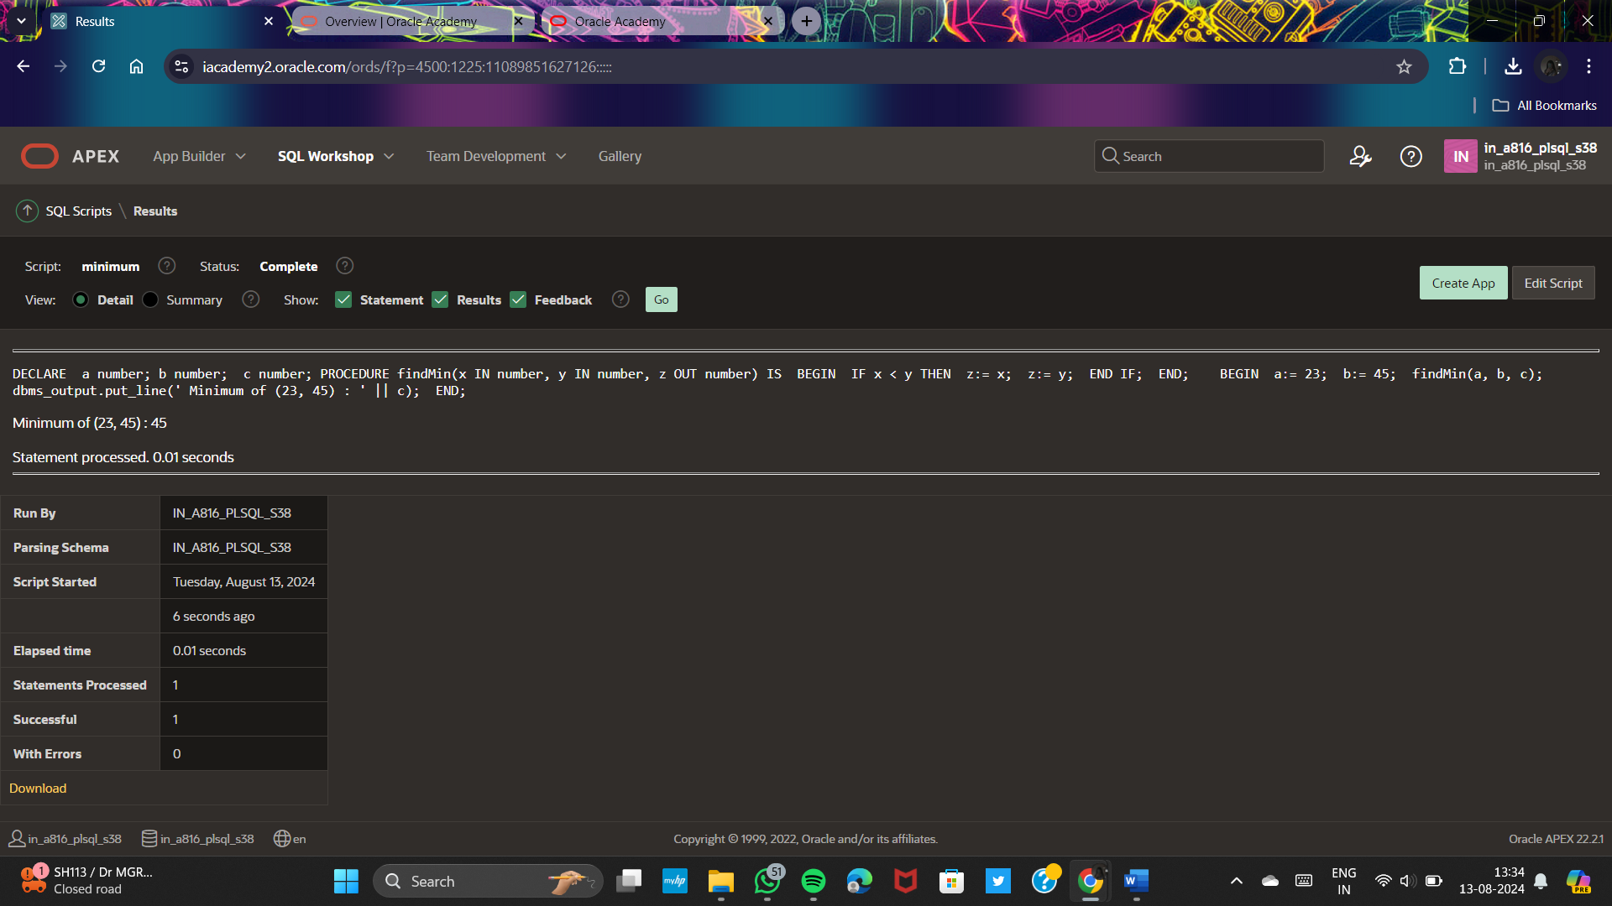

**CALCULATOR:**

DECLARE

a NUMBER;

b NUMBER;

c NUMBER;

PROCEDURE Addtwo(x IN NUMBER, y IN NUMBER, z OUT NUMBER) IS

BEGIN

z := x + y;

END;

PROCEDURE Subtwo(x IN NUMBER, y IN NUMBER, z OUT NUMBER) IS

BEGIN

z := x - y;

END;

PROCEDURE Multwo(x IN NUMBER, y IN NUMBER, z OUT NUMBER) IS

BEGIN

z := x * y;

END;

PROCEDURE Divtwo(x IN NUMBER, y IN NUMBER, z OUT NUMBER) IS

BEGIN

IF y = 0 THEN

DBMS_OUTPUT.PUT_LINE('Error: Division by zero.');

RETURN;

ELSE

z := TRUNC(x / y);

END IF;

END;

PROCEDURE Modtwp(x IN NUMBER, y IN NUMBER, z OUT NUMBER) IS

BEGIN

z := MOD(x, y);

END;

BEGIN

a := 36;

b := 14;

Addtwo(a, b, c);

DBMS_OUTPUT.PUT_LINE('Addition of (36, 14): ' || c);

Subtwo(a, b, c);

DBMS_OUTPUT.PUT_LINE('Difference between (36, 14): ' || c);

Multwo(a, b, c);

DBMS_OUTPUT.PUT_LINE('Product of (36, 14): ' || c);

b := 12;

Divtwo(a, b, c);

DBMS_OUTPUT.PUT_LINE('Quotient of (36, 12): ' || c);

Modtwp(a, b, c);

DBMS_OUTPUT.PUT_LINE('Remainder of (36, 12): ' || c);

END;

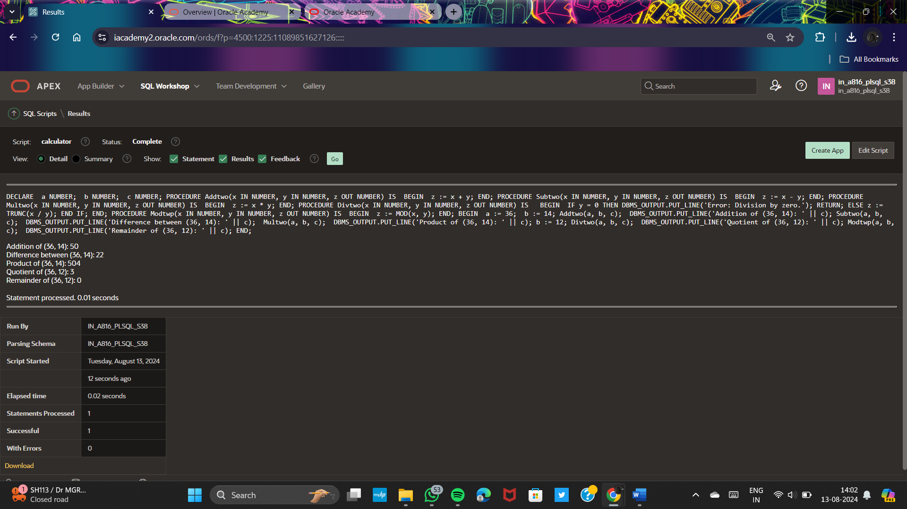

**FACTORIAL OF A NUMBER (functions):**

DECLARE

num number;

factorial number;

FUNCTION fact(x number)

RETURN number

IS

f number;

BEGIN

IF x=0 THEN

f := 1;

ELSE

f := x * fact(x-1);

END IF;

RETURN f;

END;

BEGIN

num:= 6;

factorial := fact(num);

dbms_output.put_line(' Factorial '|| num || ' is ' || factorial);

END;

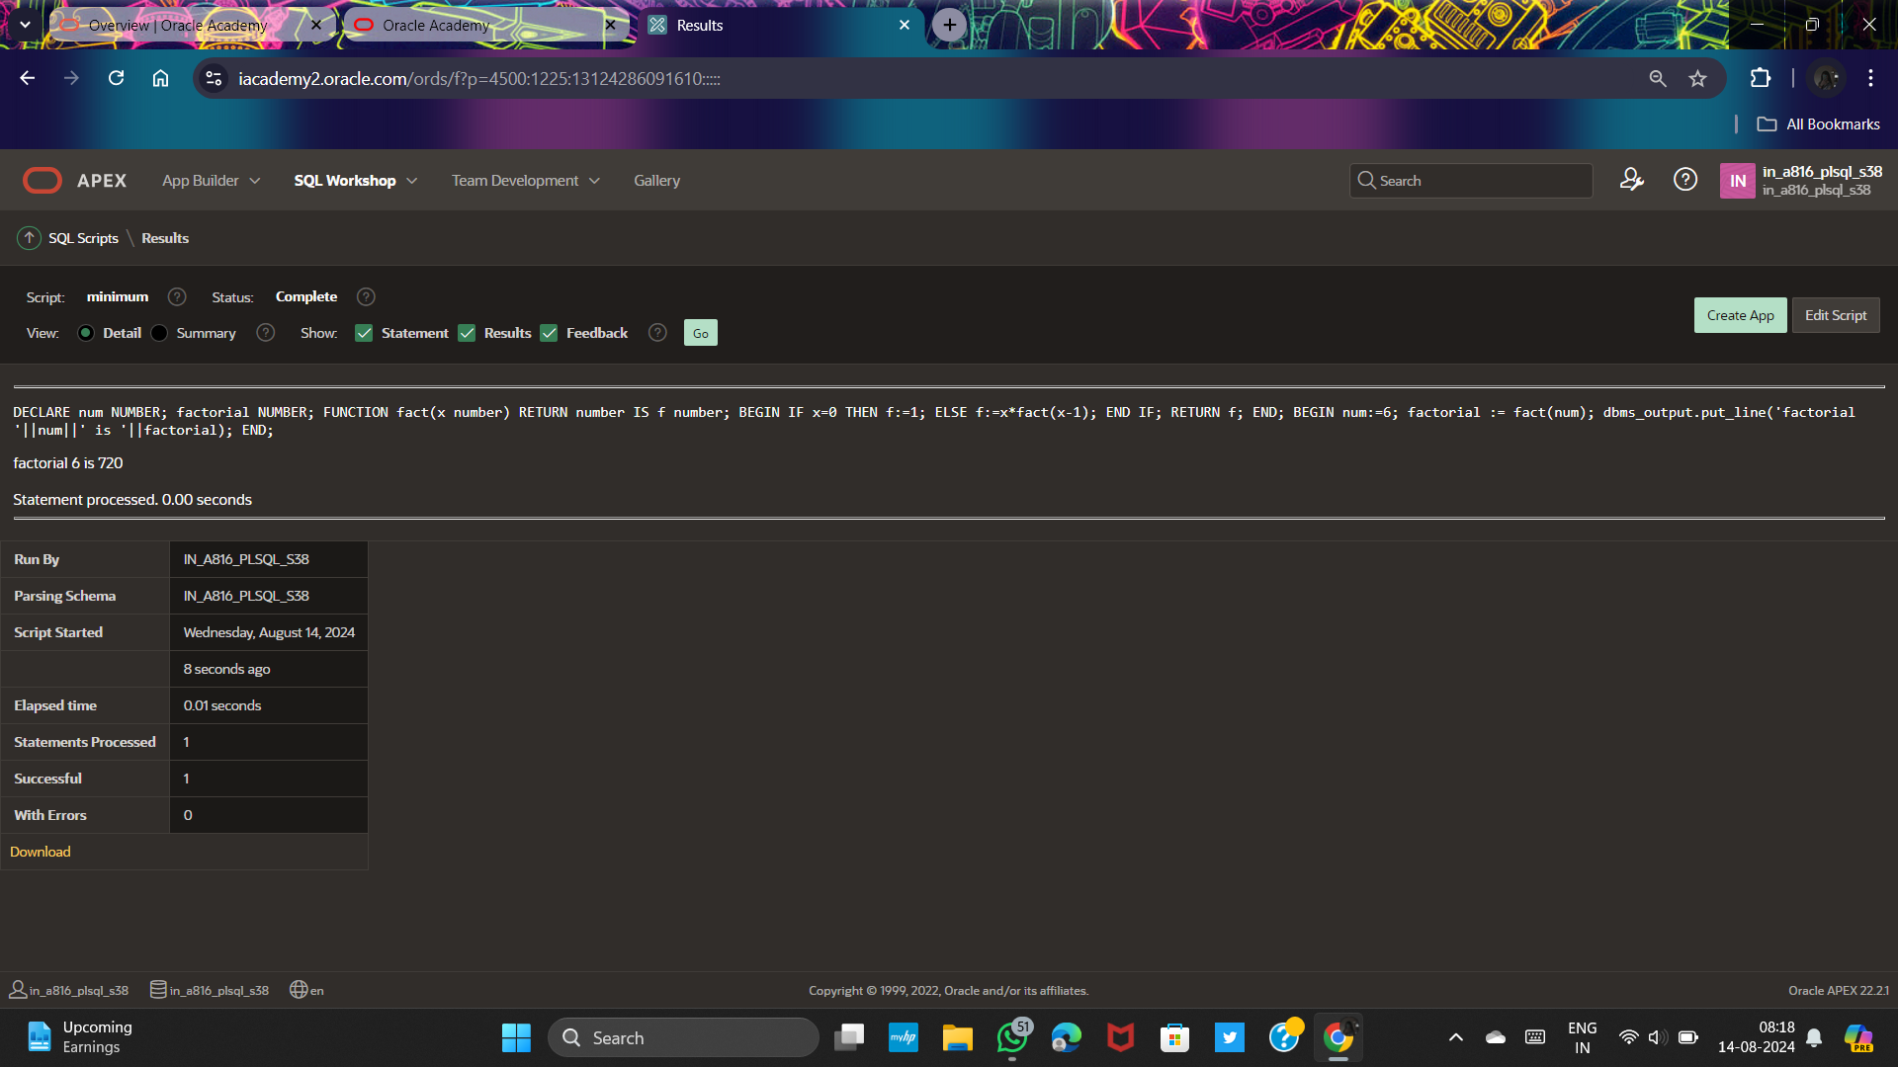

**FIND MAXIMUM :**

DECLARE

a number;

b number;

c number;

FUNCTION findMax(x IN number, y IN number)

RETURN number

IS

z number;

BEGIN

IF x > y THEN

z:= x;

ELSE

Z:= y;

END IF;

RETURN z;

END;

BEGIN

a:= 23;

b:= 45;

c := findMax(a, b);

dbms_output.put_line(' Maximum of (23,45): ' || c);

END;

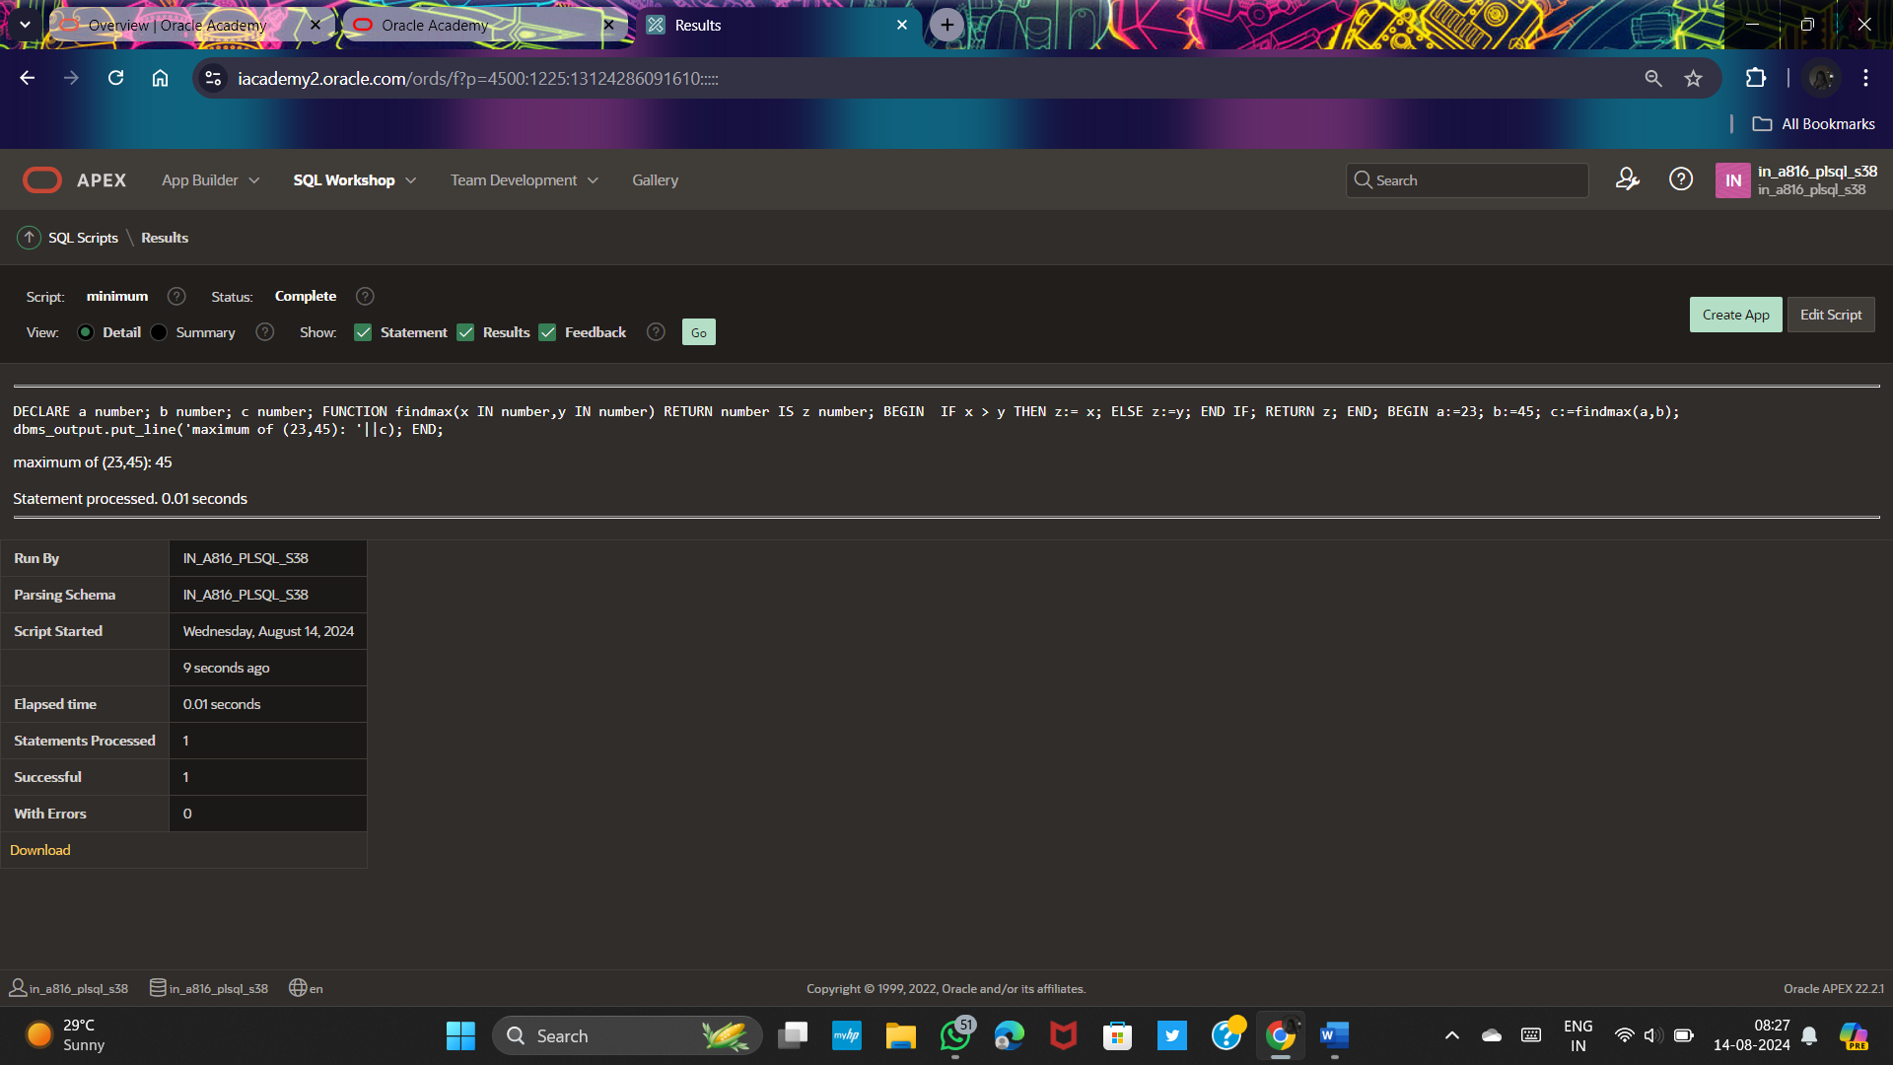

DECLARE

num number;

factorial number;

FUNCTION fact(x number)

RETURN number

IS

f number;

BEGIN

IF x=0 THEN

f := 1;

ELSE

f := x * fact(x-1);

END IF;

RETURN f;

END;

BEGIN

num:= 6;

factorial := fact(num);

dbms_output.put_line(' Factorial '|| num || ' is ' || factorial);

END;

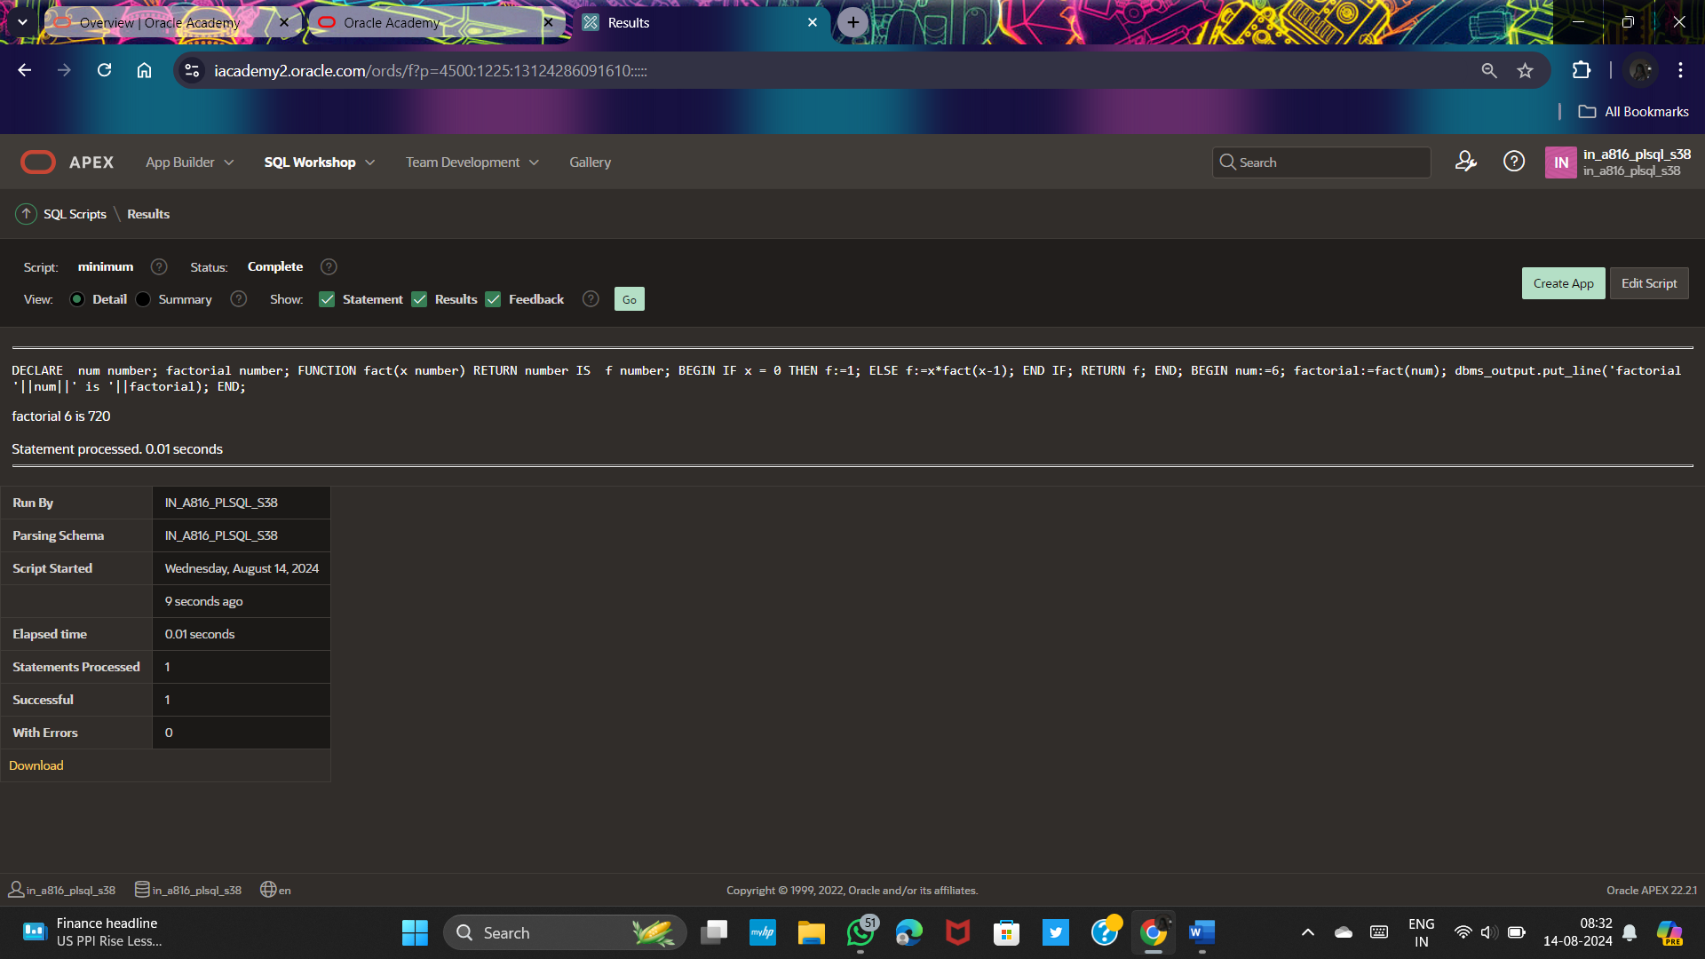

**FIBONACCI USING RECURSION:**

CREATE OR REPLACE FUNCTION fibonacci(n IN NUMBER) RETURN NUMBER IS

result NUMBER;

BEGIN

IF n <= 0 THEN

result := 0;

ELSIF n = 1 THEN

result := 1;

ELSE

result := fibonacci(n - 1) + fibonacci(n - 2);

END IF;

RETURN result;

END;

/

DECLARE

num_terms NUMBER := 10;

i NUMBER;

fib_num NUMBER;

BEGIN

FOR i IN 1..num_terms LOOP

fib_num := fibonacci(i);

DBMS_OUTPUT.PUT_LINE('Fibonacci term ' || i || ' : ' || fib_num);

END LOOP;

END;

/

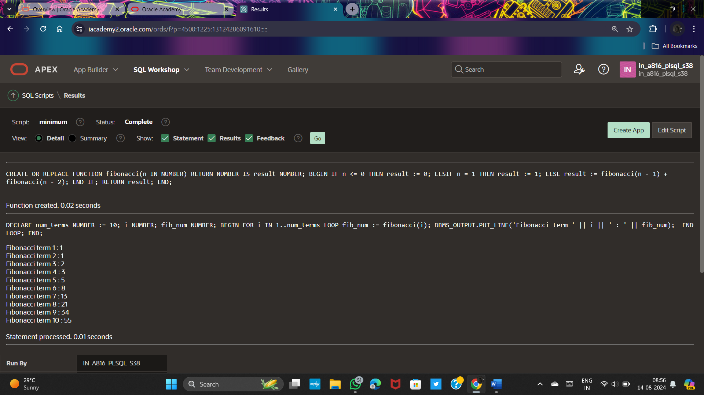

DECLARE

c_emp_id empl.EMPLOYEE_ID%TYPE;

c_fname empl.FIRSTNAME%TYPE;

c_lname empl.LASTNAME%TYPE;

c_deptid empl.DEPTID%TYPE;

CURSOR c_employee IS

SELECT EMPLOYEE_ID, FIRSTNAME, LASTNAME, DEPTID

FROM empl;

BEGIN

OPEN c_employee;

LOOP

FETCH c_employee INTO c_emp_id, c_fname, c_lname, c_deptid;

EXIT WHEN c_employee%NOTFOUND;

DBMS_OUTPUT.PUT_LINE(c_emp_id || ' ' || c_fname || ' ' || c_lname || ' ' || c_deptid);

END LOOP;

CLOSE c_employee;

END; 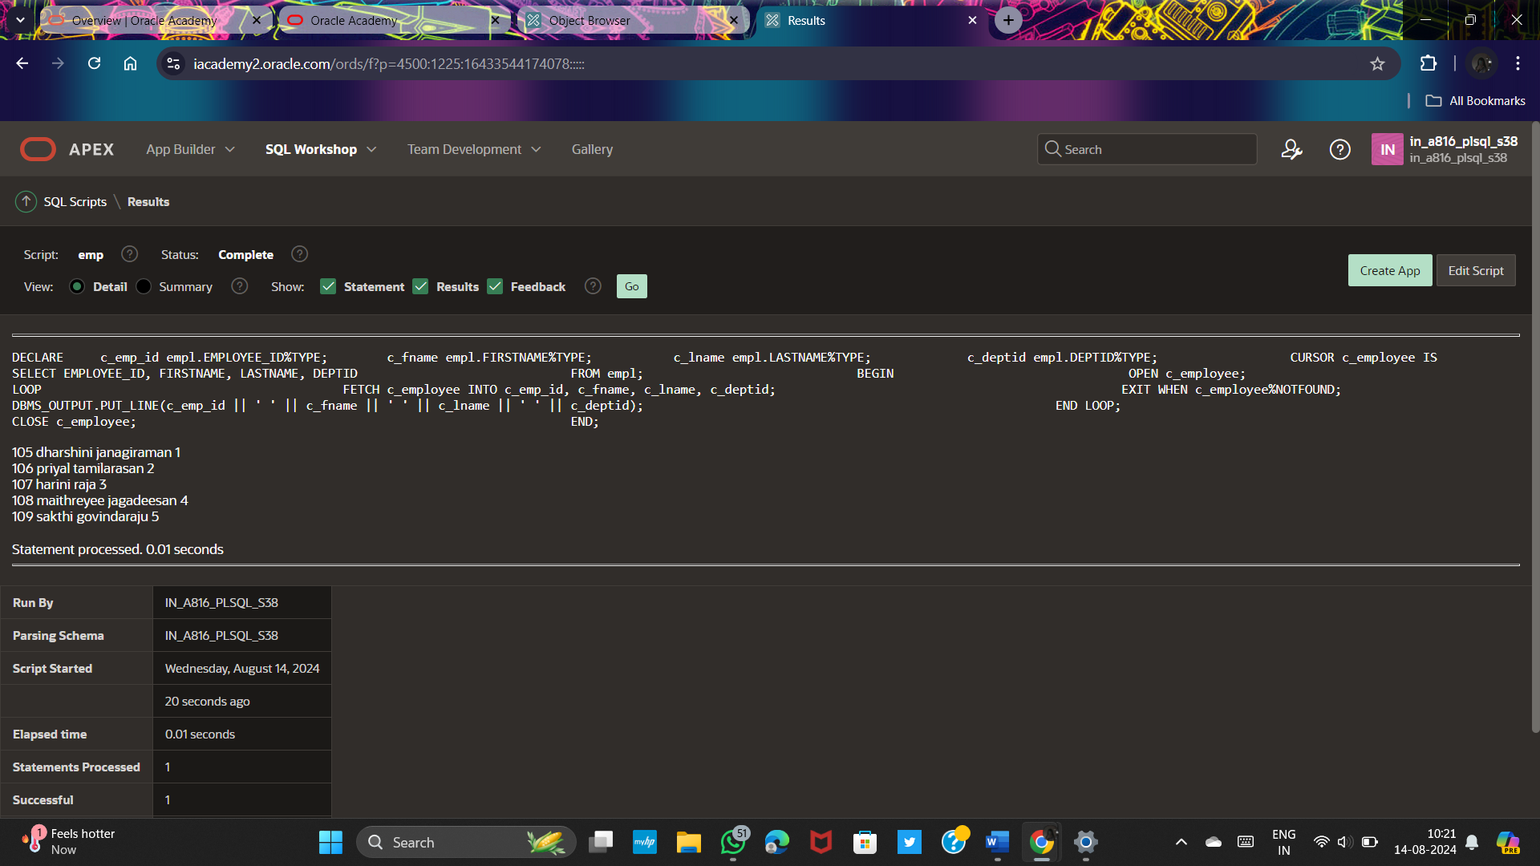

DECLARE

c_person_id person.PERSON_ID%TYPE;

c_person_name person.PERSON_NAME%TYPE;

c_email person.EMAIL%TYPE;

c_phone_number person.PHONE_NUMBER%TYPE;

CURSOR c_persons IS

SELECT PERSON_ID, PERSON_NAME, EMAIL, PHONE_NUMBER

FROM person;

BEGIN

OPEN c_persons;

LOOP

FETCH c_persons INTO c_person_id, c_person_name, c_email, c_phone_number;

EXIT WHEN c_persons%NOTFOUND;

DBMS_OUTPUT.PUT_LINE(c_person_id || ' ' || c_person_name || ' ' || c_email || ' ' || c_phone_number);

END LOOP;

CLOSE c_persons;

END;

